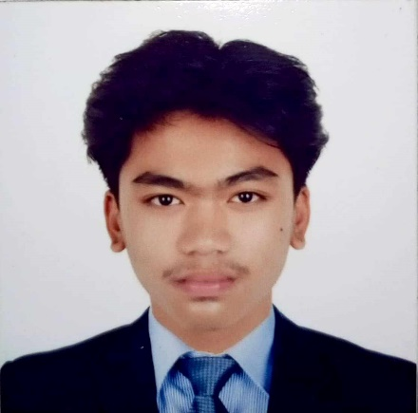

KELVIN LEE P. CLEMENTE
Address: PUROK 3, PULONGYANTOK, ANGAT, BULACAN
Hand Phone No. 09514200340
Email Address: clementekelvinlee@gmail.com

OBJECTIVE:

To be part of company that will provide an opportunity to develop more my skills and experience and gain more knowledge and be able to contribute to the advancement of the company.

PERSONAL DATA

Age: 19
Gender: Male
Birthday: August 10, 2004
Height: 5’9
Weight: 63 kg
Birthplace: Norzagaray, Bulacan
Civil Status: Single
Citizenship: Filipino
Religion: Born Again Christian
Mother’s Name: Reycie Jane P. Clemente
Occupation: House Wife
Father’s Name: Roland SP. Clemente
Occupation: Driver

SKILLS
- Ability to communicate well to others
- Computer literate
- Willing to stretch existing working hours to
accommodate work
- Flexible in any work

EDUCATIONAL BACKGROUND

Senior High Education
- Angel M. Del Rosario High School
SHS Graduate 2021-2022
Secondary Education
- Angel M. Del Rosario High School
HS Graduate 2019-2020
Primary Education
- Kaypian Elementary School
Elementary Graduate 2014-2015

WORK EXPERIENCE

2023 - Lazada sorter (STM Hub)
2022 - Lazada sorter (MSC Hub)
2022 - Work Immersion
2020 - Mineral Water Refilling Station

CHARACTER REFERENCES

Ms. Mel Rose R. Bacsal
09957138695
Licensed Professional Teacher

Ms. Maricel SP. Clemente
09491949454
Certified Public Accountant

Ms. Louella C. Goli Cruz
09308662542
Site Electrical Engineer

I hereby certify that the above information is true and correct to the best of my knowledge and belief.

KELVIN LEE P. CLEMENTE
Applicant

